# Ideation document

## Language learning website

Purpose: In this term I want to create a language learning website like Duolingo and Lingualeo where you can learn new vocabulary and play simple language games.

## [Git link](https://git.fhict.nl/I457345/languagelearning.git)

<https://git.fhict.nl/I457345/languagelearning.git>

## Website URL:

<https://i457345.luna.fhict.nl>

<Content>: words, their definitions and word games

Content variation: two types of games: gather word from jumbled letters and make as many

## Sitemap:

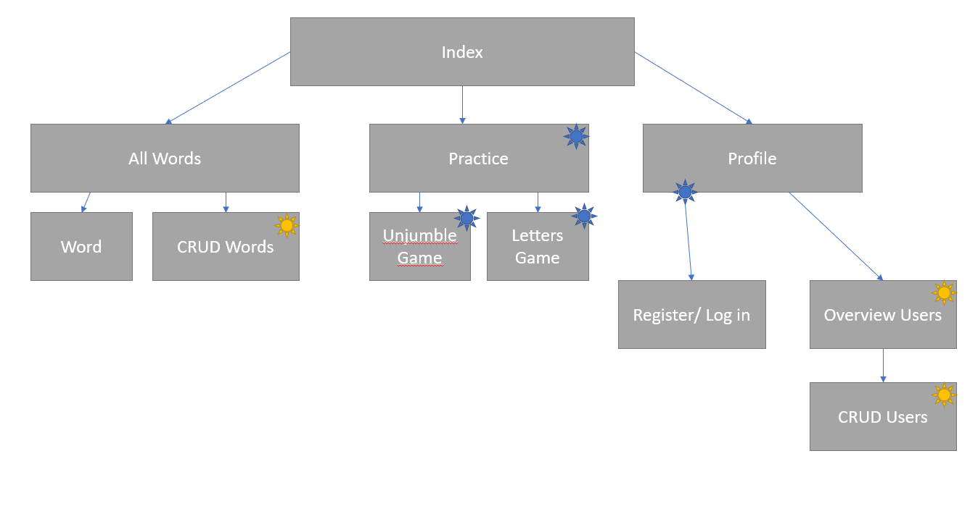

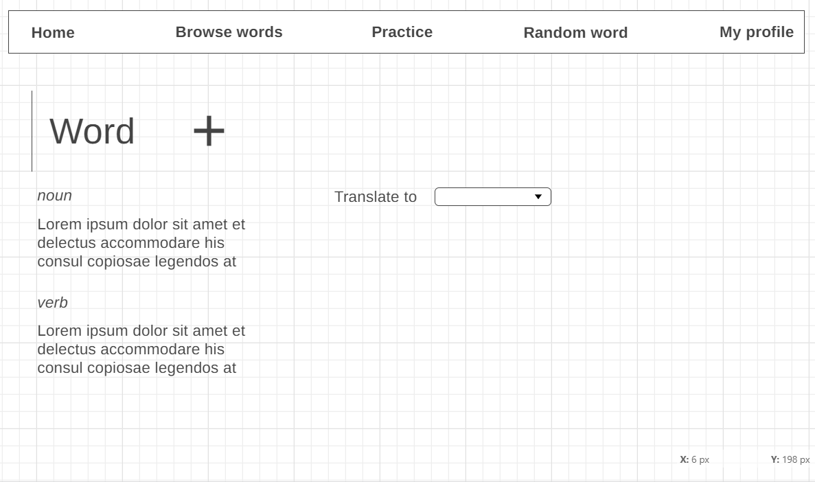Si